Software Requirements and Design Document

For

Group 1

Version 2.0

Authors:
Matthew C.
Mawi O.
Richard D.
John S.
Hector M.

1. Overview (5 points)
Gym Logger is a web app for tracking workouts. A user makes an account, logs in, and can look through an exercise library, build workout templates, and log workouts set by set (weight and reps). Past workouts are saved in a history, and a stats page shows things like total volume, workouts per week and personal records. Each user only sees their own data.
Increment 2 adds a home page with recent workouts, account management (edit profile, change password, delete account), an exercise detail page, editing and duplicating templates, a bigger exercise library, more statistics, and error pages.

2. Functional Requirements (10 points)
Priority is in brackets at the end of each requirement.
- A visitor can register with a username, email and password (at least 8 characters, typed twice). Empty fields, a bad email, passwords that don't match, or a username or email that is already taken are rejected with a message. After registering the user is logged in. (High)
- A user can log in with a username and password and log out. A wrong login just shows "Invalid username or password." (High)
- Passwords are stored as hashes, never as plain text. (High)
- Every page except register and login needs the user to be logged in. Logged out visitors get sent to the login page. (High)
- The home page shows the user's five most recent workouts (template name or "Freestyle workout", date, number of sets) with links, plus shortcuts to start a workout and browse exercises. Visitors see register and login links instead. (Medium)
- The home page also has a small stats summary, like workouts this week and total volume. (Low)
- A user can open an account page and change their username and email. The same rules as registration apply, and they can keep their current values. (Medium)
- A user can change their password by entering the current one and then a new one twice. The new one needs 8 or more characters and has to be different from the old one. (Medium)
- A user can delete their account by entering their password and confirming. This deletes their templates, workouts and sets, but nobody else's data. (Medium)
- The exercise library lists every exercise with its name, category and muscle group, sorted by name. (High)
- The library can be searched by name and filtered by category and muscle group, alone or together. (High)
- The library should start with at least 40 exercises that cover all muscle groups and categories. Running the seed script again should not create duplicates. (Medium)
- A user can open a detail page for an exercise that shows its info plus their own best set and recent sets for it. (Medium)
- A user can create a workout template with a name (unique among their own templates) and at least one exercise from the library, kept in the order they picked. (High)
- A user can view their templates and see the exercises in each one. (High)
- A user can edit a template: rename it and add, remove or reorder its exercises. (Medium)
- A user can duplicate a template. The copy has the same exercises and is named "<name> (copy)". (Low)
- A user can delete a template after confirming. Workouts already logged from it are kept. (High)
- A user can start a workout, with or without one of their templates. The date is saved automatically. (High)
- A user can add sets to a workout by picking an exercise and entering a weight (0 or more) and reps (a whole number, 1 or more). Sets are numbered per exercise. Bad input is rejected with a message. (High)
- If a workout was started from a template, its exercises show as a checklist and get marked done once a set is logged for them. (Medium)
- A user can see a list of their past workouts, newest first, and open one to see its sets. (High)
- A stats page shows the user's total workouts, total volume (weight x reps), volume per workout, workouts per week for the last 8 weeks, sets per muscle group, and personal records. A user with no workouts should see zeros or a message, not an error. (Medium)
- The system shows a message when something works or gets rejected, and a simple error page with a link home for 403, 404 and 500 errors. (Medium)
A template is optional when starting a workout so people can just start logging. Deleting a template doesn't delete past workouts so history and stats don't get lost.

3. Non-functional Requirements (10 points)
- Security: users can only see and change their own data. Asking for someone else's template or workout gives the same "not found" page as something that doesn't exist.
- Security: form input is checked on the server before it is saved, and database queries go through the ORM instead of building SQL from user input.
- Usability: a new user should be able to register, start a workout and log a set without any instructions. Every page uses the same navigation bar and errors are written in plain language.
- Usability: pages should work on a phone as well as a desktop browser.
- Portability: it should work in current versions of Chrome, Firefox, Safari and Edge with JavaScript on.
- Reliability: data is saved to the database right away and is still there after the server restarts. If a request fails, nothing should be half saved.
- Performance: pages should load in about a second with the full exercise library and a user with up to 1,000 logged sets.
- Maintainability: the code is split by feature (auth, exercises, templates, workouts), the stats calculations are in their own module, and every feature has pytest tests that pass before changes are merged.

4. Use Case Diagram (10 points)
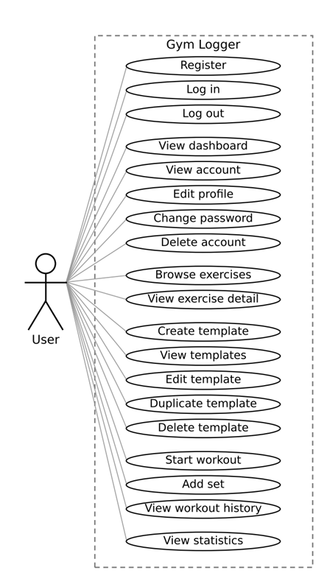
Use case descriptions
The actor in every use case is the User. Unless it says otherwise, the user is logged in first.
Register
- Before: Visitor is not logged in.
- Steps: Open the register page, enter username, email, password and confirmation, and submit. The account is created and the user lands on the home page logged in.
If something goes wrong: Empty field, bad email, short password, passwords don't match, or username/email already taken: the form shows again with an error and nothing is created.
Log in
- Before: User has an account.
- Steps: Enter username and password and submit. The user lands on the home page.
If something goes wrong: Wrong login shows "Invalid username or password."
Log out
- Steps: Click logout. The user is sent to the login page.
View dashboard
- Before: Visitors can open it too but only see register and login links.
- Steps: Open the home page. It shows a welcome message, shortcuts, a stats summary and the five most recent workouts.
If something goes wrong: No workouts yet shows "No workouts yet".
View account
- Steps: Open the account page. It shows the join date, number of workouts, and the forms for editing the profile, changing the password and deleting the account.
Edit profile
- Steps: Change the username and/or email and submit. The page says "Profile updated."
If something goes wrong: Empty field, bad email, or a username/email that someone else has: error and nothing changes. Keeping the current values is fine.
Change password
- Steps: Enter the current password, then the new password twice, and submit.
If something goes wrong: Wrong current password, under 8 characters, passwords don't match, or same as the old one: error and the password stays the same.
Delete account
- Steps: Enter the password, submit and confirm the warning. The account and all its data are deleted and the user is logged out.
If something goes wrong: Cancelling does nothing. A wrong password shows an error and the account stays.
Browse exercises
- Steps: Open the Exercises page. The list is sorted by name. The user can type a search and pick a category and/or muscle group to narrow it down.
If something goes wrong: No match shows a "no exercises found" message.
View exercise detail
- Before: The exercise exists.
- Steps: Click an exercise in the library. The page shows its info, the user's best set and their recent sets for it.
If something goes wrong: Never logged it: shows no history yet. Bad exercise id: 404 page.
Create template
- Steps: Open New template, enter a name, pick exercises and submit. The template is saved and shown.
If something goes wrong: Empty name, name over 120 characters, no exercises picked, or name already used: error and what was entered is kept.
View templates
- Steps: Open Templates and pick one. It shows the exercises in order and buttons to start a workout, edit, duplicate or delete it.
If something goes wrong: No templates yet shows a prompt to make one. Someone else's template gives a 404 page.
Edit template
- Before: User owns the template.
- Steps: Click Edit, change the name and/or exercises and submit. The changes are saved.
If something goes wrong: Same checks as creating a template, except keeping its own name is fine.
Duplicate template
- Before: User owns the template.
- Steps: Click Duplicate. A new template is made with the same exercises, named "<name> (copy)" (with a number added if that name exists). The original isn't touched.
Delete template
- Before: User owns the template.
- Steps: Click Delete and confirm. The template is removed. Workouts logged from it stay.
If something goes wrong: Cancelling does nothing.
Start workout
- Steps: Open New workout, optionally pick one of the templates, and start. The workout page opens, with a checklist if a template was used.
If something goes wrong: Template isn't the user's: error and no workout is created.
Add set
- Before: A workout is open.
- Steps: Pick an exercise, enter weight and reps and submit. The set shows up under its exercise.
If something goes wrong: No exercise, weight not a number or negative, or reps not a whole number of 1 or more: error and nothing is saved.
View workout history
- Steps: Open Workouts. Past workouts are listed newest first, and clicking one shows its sets grouped by exercise.
If something goes wrong: No workouts shows a message and a link to start one. Someone else's workout gives a 404 page.
View statistics
- Steps: Open the Stats page. It shows the numbers listed in requirement 23, worked out from the user's own sets.
If something goes wrong: No workouts shows zeros or a message instead of an error.

5. Class Diagram and/or Sequence Diagrams (15 points)
Class Diagram: Database Models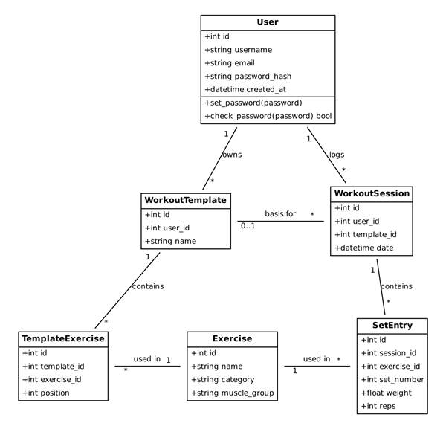

Each class below is a database table (SQLAlchemy models). A user owns many templates and logs many workouts. A workout can optionally be based on a template. TemplateExercise connects a template to an exercise and keeps the order. A SetEntry is one set of one exercise in one workout.
Sequence Diagram: Login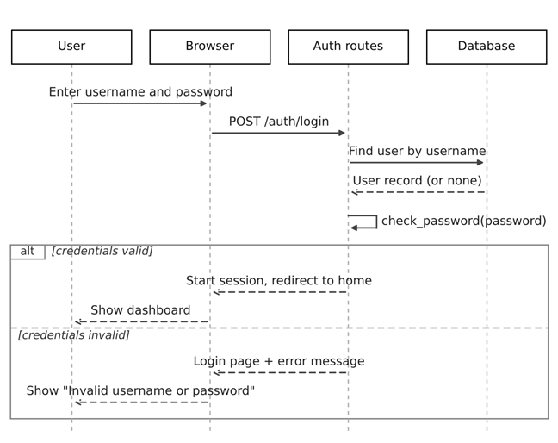

Sequence Diagram: Workout Template Creation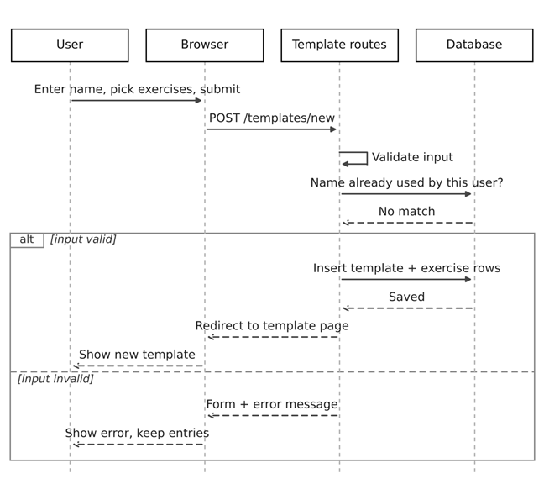

Sequence Diagram: Logging a Workout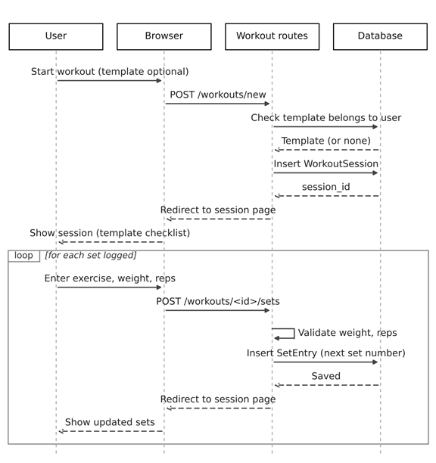

6. Operating Environment (5 points)
The app runs on any computer with Python 3.10 or newer and is used through a web browser (Chrome, Firefox, Safari or Edge) with JavaScript turned on. It uses a local SQLite database, though PostgreSQL could be used by setting DATABASE_URL. Right now it only runs locally.

7. Assumptions and Dependencies (5 points)
Assumptions
- Users know how to use a normal website (menus, forms, navigation bar)
- Everyone running the app has a working Python 3.10+ setup
- SQLite is enough for our scale
- Weights are entered in pounds
- One account is one person, there is no sharing or admin role
Dependencies
- See requirements.txt (Flask, Flask-SQLAlchemy, Flask-Login, pytest). Specific versions may be needed
- No third party APIs and no cloud hosting

